For immediate release
Date 29.04.2010

PRESS RELEASE

LOUTH STREET NAMES WIN

PRIDE OF PLACE AWARD

Louth’s street nameplates, recast to the original Victorian designs, have been awarded one of Louth Civic Trust’s prestigious Pride of Place awards. The award was presented to Jean Howard and John Stainton at the Trust’s AGM on Thursday 29th April in recognition of their unwavering commitment to a ten year project to re-instate the town’s lost signs.

Chairman of Louth Civic Trust, James Laverack, “The new street nameplates have had a significant impact on the character of our Conservation Area. Louth’s famous panorama artist William Brown campaigned for the installation of the original signs during the town’s rapid expansion in the 19th century. “

“…When looking at the finished signs, it is difficult to appreciate the work that went into ensuring they are exactly like the originals. In the absence of any moulds for the unique typeface used on Louth’s signs, each letter had to be researched and redrawn, each missing sign and name had to be identified, often through archive material and a foundry had to be found to make the signs using the original sand casting techniques. By giving this award to Jean and John, it will go some way to thanking them for their time, perseverance and attention to detail that has made this project such a success.”

The street nameplate project was completed in October last year. It was spearheaded by Jean Howard and John Stainton of Louth Civic Trust with funding from East Lindsey District Council, Louth Town Council and The Gatherums Regeneration Partnership.

A second award was presented to Mary Finch in memory of her late husband Cllr Clive Finch in recognition of his services to our local heritage during his many years as a Councillor.

The AGM also included a fascinating lecture by Liz Bates, Historic Buildings Manager entitled ‘Lincolnshire Heritage at Risk’ and Louth Civic Trust announced the launch of a campaign to increase involvement in the activities of the Trust and its aim to encourage an appreciation of the town’s unique social and architectural heritage.

For further information on the activities of Louth Civic Trust call James Laverack Chairman on Tel. 01507 603648.

ENDS

Contacts:
For further information contact James Laverack Chairman of Louth Civic Trust at John Taylors tel. 01673 844249 or mobile number 07958 453636, email marketrasen@johntaylors.com

Notes to editor:

Photo call featured
President of Louth Civic Trust, David Robinson OBE presenting Pride of Place awards to:
Trust members Jean Howard and John Stainton for the Street Nameplate project
Mary Finch in recognition of the services to our local heritage of the late Cllr Clive Finch

Additional images available in jpg format : sample of re-cast streetname plates
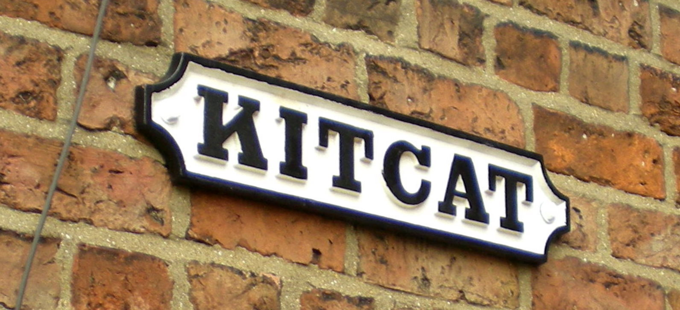

Louth Civic Trust was established in 1967. It is a local charity encouraging community pride and passion, for the history and identity of its buildings, streets and public places and aims to protect and manage change in the town’s landscape and architectural heritage through its key activities of campaigning, education and action.

The Pride of Place Award Scheme was introduced by the Louth Civic Trust to recognise the achievement and commitment of those who have made a difference to the quality of the town’s built environment.

